Question 1.

class Array{

public static void main(String args[]){

int arr[] = {1,2,3,4,5};

int new_arr[] = arr;

f(arr,0,arr.length-1);

for(int i : arr){

System.out.print(i + " ");

}

System.out.println();

if(arr == new_arr){

f(arr,0,arr.length-1);

}

for(int i : arr){

System.out.print(i + " ");

}

}

static void f(int arr[],int s,int e){

if(s == e){

return;

}

int temp = arr[s];

arr[s] = arr[e];

arr[e] = temp;

f(arr,s+1,e-1);

}

}

Dry Run:

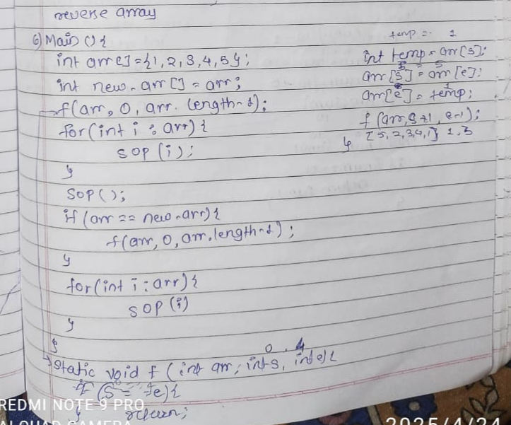

Question 2.

import java.util.*;

class Sum{

public static void main(String args[]){

Scanner sc = new Scanner(System.in);

System.out.println("Enter the number");

int num = sc.nextInt();

int sum = f(num,0);

System.out.println(sum);

}

static int f(int num,int sum){

if(num == 0){

return sum;

}

int rev = num%10;

num = num/10;

sum = sum+rev;

return f(num,sum);

}

}

Dry Run :

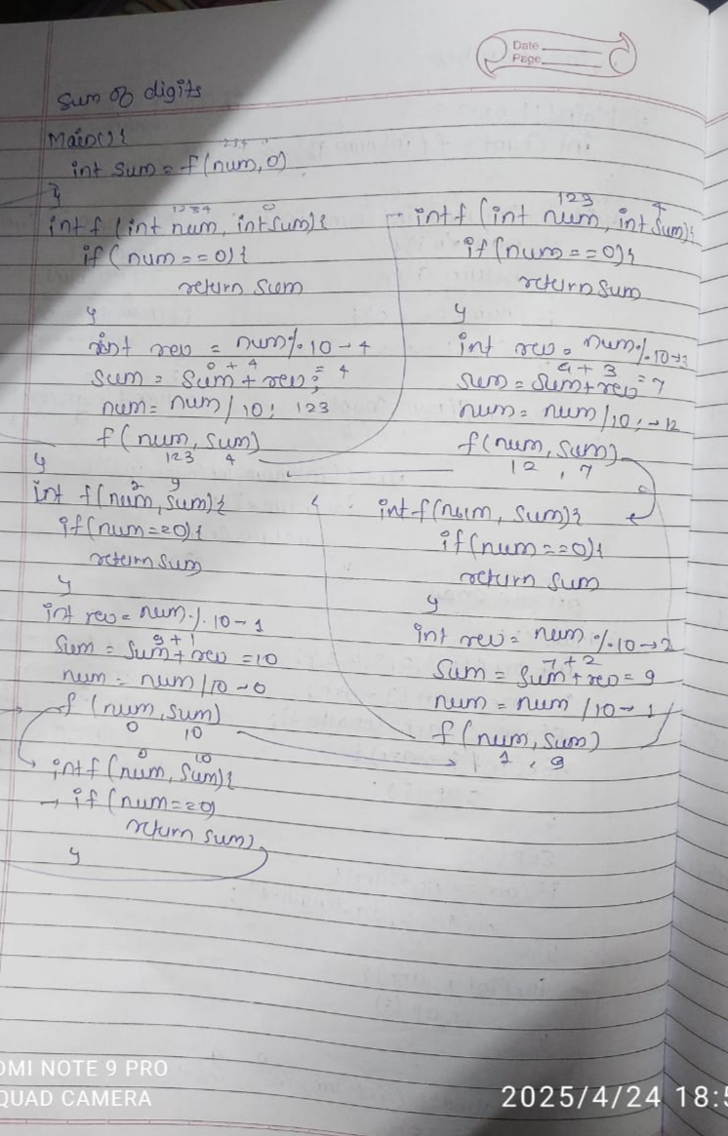

Question 3.

import java.util.*;

class Multi{

public static void main(String args[]){

Scanner sc = new Scanner(System.in);

System.out.println("Enter the number");

int num = sc.nextInt();

int multi = f(num,1);

System.out.println(multi);

}

static int f(int num,int multi){

if(num == 0){

return multi;

}

int rev = num%10;

num = num/10;

multi = multi*rev;

return f(num,multi);

}

}

Dry Run:

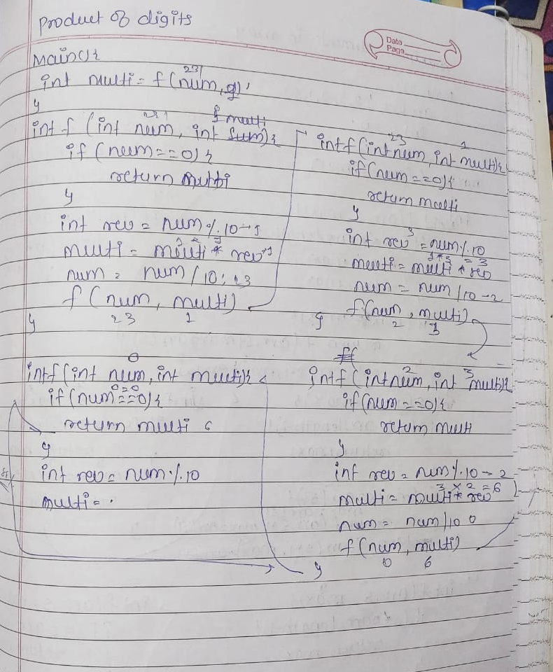

Question 4.

import java.util.*;

class Numbers{

public static void main(String args[]){

Scanner sc = new Scanner(System.in);

System.out.print("Enter the number");

int num = sc.nextInt();

f(num,0);

}

static void f(int sc,int count){

if(sc == 0){

System.out.println(count);

return ;

}

sc = sc/10;

count++;

f(sc,count);

}

}

Dry Run:

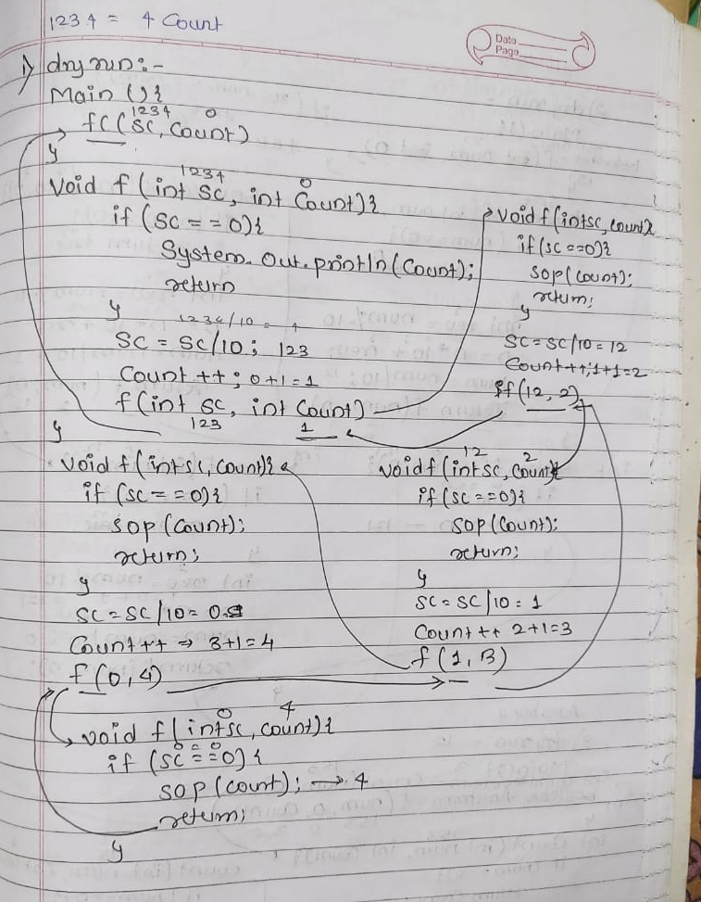

Question 5.

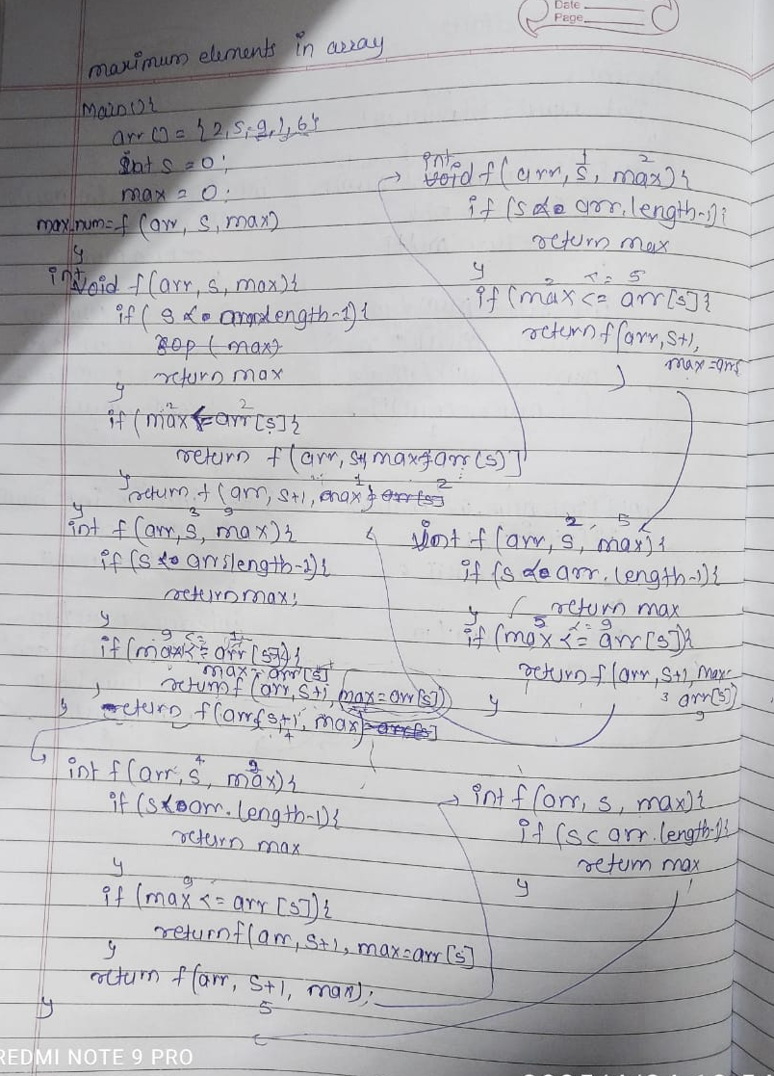

Question 6.

class SortedArray{

public static void main(String args[]){

int arr[] = {1,3,2,4};

int s =0;

int max = 0;

boolean check = f(arr,s,max);

System.out.println(check);

}

static boolean f(int arr[],int s,int max){

if(s == arr.length-1){

return true;

}

if(max<=arr[s]){

return f(arr,s+1,max=arr[s]);

}else{

return false;

}

}

}

Dry run:

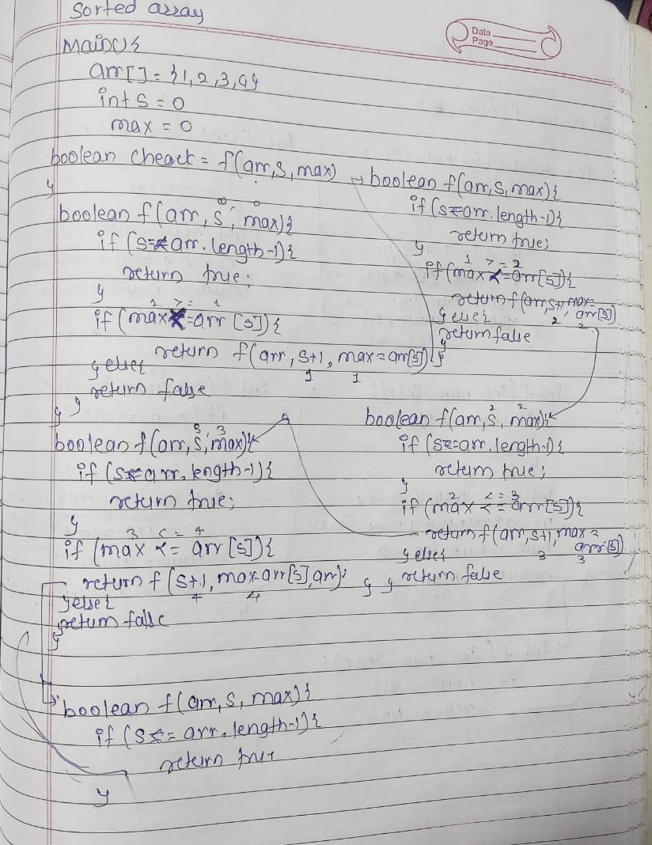

Question 7.

import java.util.*;

class Prime{

public static void main(String args[]){

Scanner sc = new Scanner(System.in);

System.out.println("Enter a number");

int num = sc.nextInt();

boolean Prime_num =f(num,1,0);

System.out.println(Prime_num);

}

static boolean f(int num,int i,int count){

if(num < i){

if(count == 2){

return true;

}

return false;

}

if(num%i == 0){

count++;

}

i++;

return f(num,i,count);

}

}

Dry run:

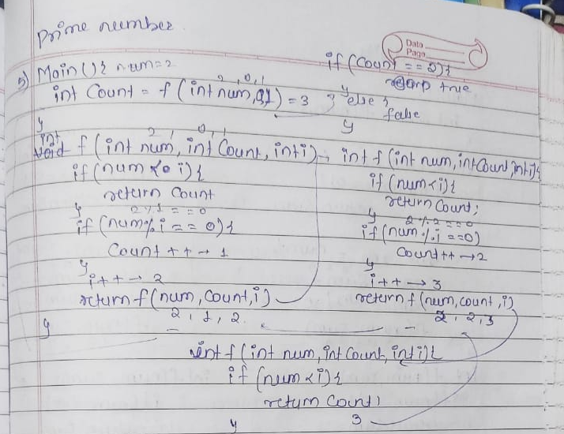

Question 8.

class Count {

public static void main(String[] args) {

int[] arr = {1, 2, 3, 2, 4, 2};

int target = 2;

int count = countNum(arr, 0, target);

System.out.println("Count: " + count);

}

static int countNum(int[] arr, int i, int num) {

if (i == arr.length)

return 0;

if (arr[i] == num)

return 1 + countNum(arr, i + 1, num);

else

return countNum(arr, i + 1, num);

}

}

Dry run:

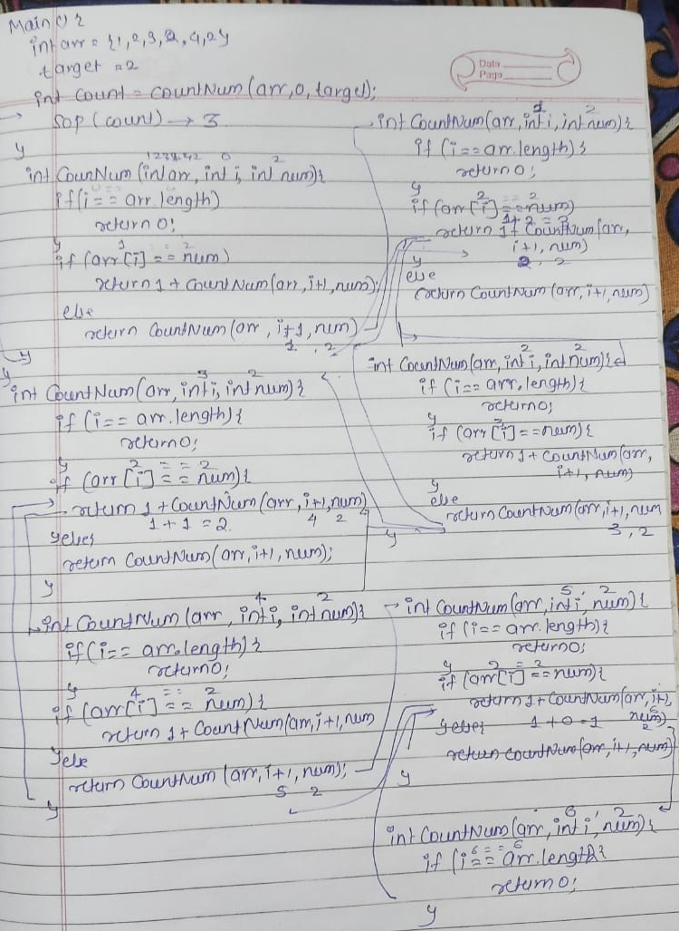

Question 9.

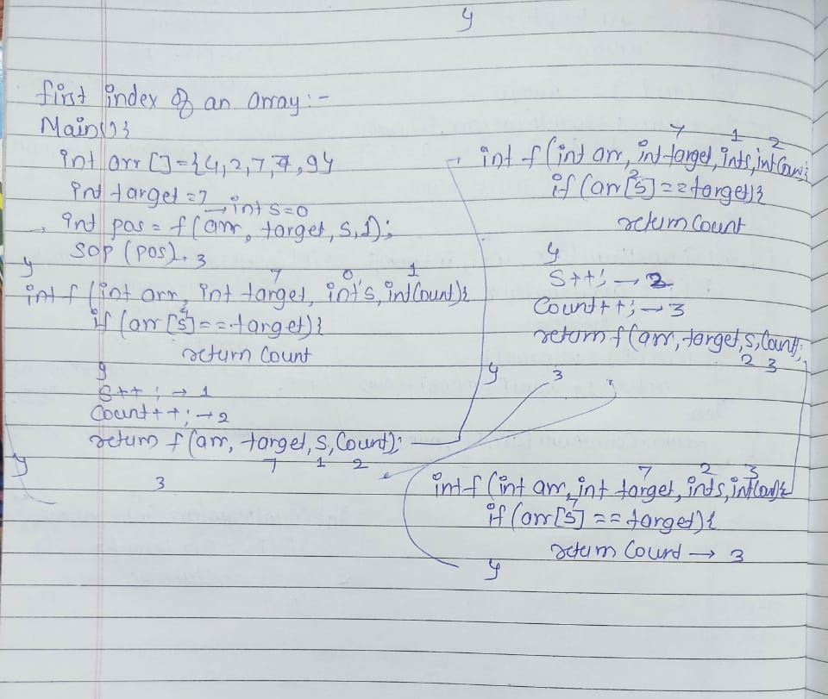

Question 10.

import java.util.*;

class Reverse{

public static void main(String args[]){

Scanner sc = new Scanner(System.in);

System.out.println("Enter the number");

int num = sc.nextInt();

f(num);

}

static void f(int num){

if(num == 0){

return;

}

int rev = num%10;

num = num/10;

System.out.print(rev);

f(num);

}

}

Dry run:

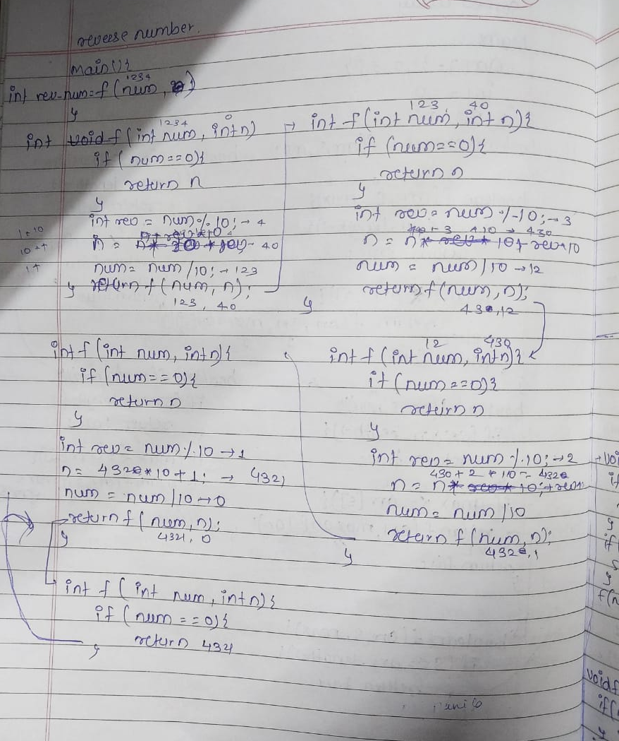

Question 11.

import java.util.*;

class CountOccurance{

public static void main(String args[]){

Scanner sc = new Scanner(System.in);

System.out.println("Enter a number");

int A = sc.nextInt();

System.out.println("Enter a number which is multiple time occure");

int D = sc.nextInt();

int count = f(A,D,0);

System.out.println(count);

}

static int f(int num,int digit,int count){

if(num == 0){

return count;

}

int rev = num%10;

if(rev == digit){

count++;

}

num = num/10;

return f(num,digit,count);

}

}

Dry run:

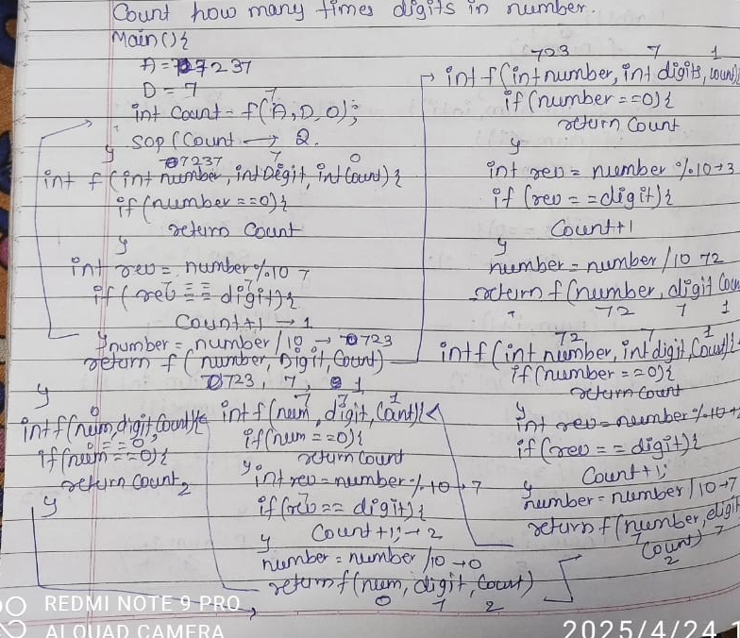

Question 12.

import java.util.*;

class Palindrom{

public static void main(String args[]){

Scanner sc = new Scanner(System.in);

System.out.println("enter the number");

int num = sc.nextInt();

int rev_num = f(num,0);

System.out.println(rev_num);

if(rev_num == num){

System.out.println("number is Palindrom");

}

else{

System.out.println("number is not Palindrom");

}

}

static int f(int num,int rev_num){

if(num == 0){

return rev_num;

}

int rev = num%10;

rev_num = rev_num*10+rev;

num = num/10;

return f(num,rev_num);

}

}

Dry run:

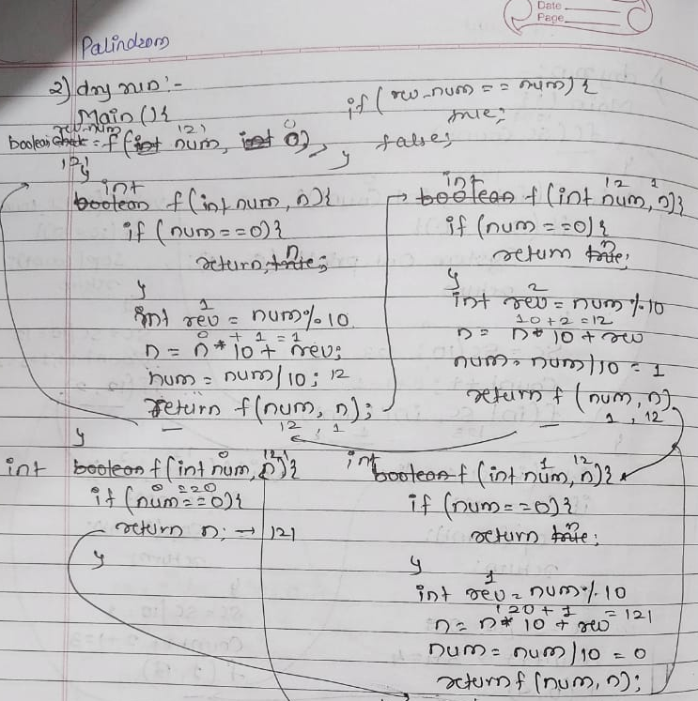

Question 14.

import java.util.*;

class Divisible{

public static void main(String args[]){

Scanner sc = new Scanner(System.in);

System.out.println("Enter a number");

int num = sc.nextInt();

f(num,1);

}

static void f(int num,int i){

if(num < i){

return;

}

if(i%3 == 0){

System.out.print(i+" ");

}

f(num,i+1);

}

}

Dry run:

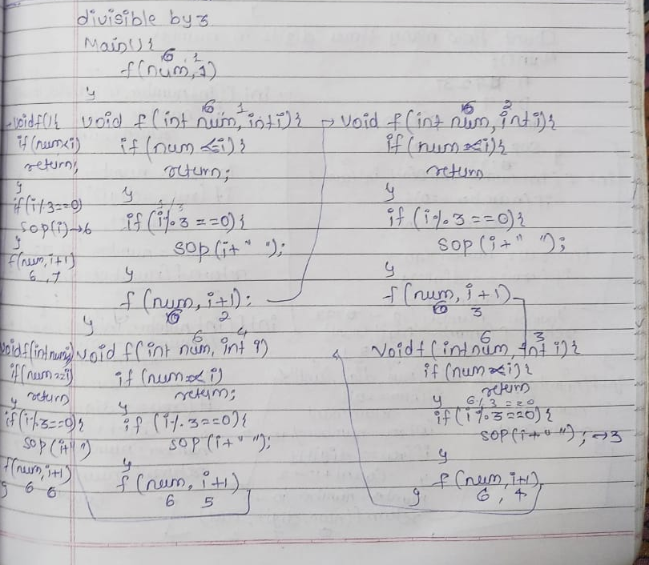

Question 15.

import java.util.*;

class Power{

public static void main(String args[]){

Scanner sc = new Scanner(System.in);

System.out.println("Enter two numbers");

int A = sc.nextInt();

int multi_num = A;

int B = sc.nextInt();

int power = f(A,B,1,multi_num);

System.out.println(power);

}

static int f(int num,int pow,int count,int multi_num){

if(pow == count){

return multi_num;

}

multi_num = multi_num*num;

return f(num,pow,count+1,multi_num);

}

}

Dry run:

